**ASSIGNMENT NO. 01**

**INTRODUCTION TO EMBEDDED MICROCONTROLLER CORES**

## **CISC (Complex Instruction Set Computer) Architecture:**

A **complex instruction set computer** is a computer in which single [instructions](https://en.wikipedia.org/wiki/Instruction_set_architecture) can execute several low-level operations (such as a load from [memory](https://en.wikipedia.org/wiki/Memory_(computers)), an [arithmetic](https://en.wikipedia.org/wiki/Arithmetic) [operation](https://en.wikipedia.org/wiki/Operator_(programming)), and a [memory store](https://en.wikipedia.org/wiki/Memory_(computers))) or are capable of multi-step operations or [addressing modes](https://en.wikipedia.org/wiki/Addressing_mode) within single instructions. The term "CISC" (complex instruction set computer or computing) refers to computers designed with a full set of computer instructions that were intended to provide needed capabilities in the most efficient way. Intel's [Pentium](https://whatis.techtarget.com/definition/Pentium) microprocessors are CISC microprocessors. The main intend of the CISC processor architecture is to complete task by using less number of assembly lines. For this purpose, the processor is built to execute a series of operations. Complex instruction is also termed as MULT, which operates [memory banks](https://www.elprocus.com/stack-memory-allocation-and-register-set-in-8051-microcontroller/)of a computer directly without making the compiler to perform storing and loading functions.

**Features of CISC Architecture**

* To simplify the computer architecture, CISC supports microprogramming.
* CISC have more number of predefined instructions which makes high level languages easy to design and implement.
* CISC consists of less number of registers and more number of addressing modes, generally 5 to 20.
* CISC processor takes varying cycle time for execution of instructions – multi-clock cycles.
* Because of the complex instruction set of the CISC, the pipelining technique is very difficult.
* CISC consists of more number of instructions, generally from 100 to 250.
* Special instructions are used very rarely.
* Operands in memory are manipulated by instructions.

**Advantages of CISC architecture**

* Each machine language instruction is grouped into a microcode instruction and executed accordingly, and then are stored inbuilt in the memory of the main processor, termed as microcode implementation.
* As the microcode memory is faster than the main memory, the microcode instruction set can be implemented without considerable speed reduction over hard wired implementation.
* Entire new instruction set can be handled by modifying the micro program design.
* CISC, the number of instructions required to implement a program can be reduced by building rich instruction sets and can also be made to use slow main memory more efficiently.
* Because of the superset of instructions that consists of all earlier instructions, this makes micro coding easy.

**Drawbacks of CISC**

* The amount of clock time taken by different instructions will be different – due to this – the performance of the machine slows down.
* The instruction set complexity and the chip hardware increases as every new version of the processor consists of a subset of earlier generations.
* Only 20% of the existing instructions are used in a typical programming event, even though there are many specialized instructions in existence which are not even used frequently.
* The conditional codes are set by the CISC instructions as a side effect of each instruction which takes time for this setting – and, as the subsequent instruction changes the condition code bits – so, the compiler has to examine the condition code bits before this happens.

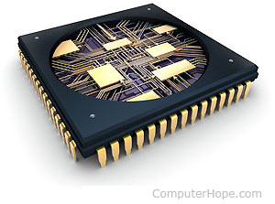

**Figure A1.1: CISC**

## **RISC (Reduced Instruction Set Computer) Architecture:**

The [microcontroller architecture](https://www.elprocus.com/8051-microcontroller-architecture-and-applications/) that utilizes small and highly optimized set of instructions is termed as the Reduced Instruction Set Computer or simply called as RISC. It is also called as LOAD/STORE architecture. In the late 1970s and early 1980s, RISC projects were primarily developed from Stanford, UC-Berkley and IBM. The John Coke of IBM research team developed RISC by reducing the number of instructions required for processing computations faster than the CISC. The RISC architecture is faster and the chips required for the manufacture of RISC architecture is also less expensive compared to the CISC architecture.

**Typical Features of RISC Architecture**

* Pipelining technique of RISC, executes multiple parts or stages of instructions simultaneously such that every instruction on the CPU is optimized. Hence, the RISC processors have Clock per Instruction of one cycle, and this is called as One Cycle Execution.
* It optimizes the [usage of register](https://www.elprocus.com/know-about-types-of-registers-in-8051-microcontroller/) with more number of registers in the RISC and more number of interactions within the memory can be prevented.
* Simple addressing modes, even complex addressing can be done by using arithmetic [AND/ OR logical operations](https://www.elprocus.com/different-types-of-digital-logic-circuits/).
* It simplifies the compiler design by using identical general purpose registers which allows any register to be used in any context.
* For efficient usage of the registers and optimization of the pipelining uses, reduced instruction set is required.
* The number of bits used for the opcode is reduced.
* In general there are 32 or more registers in the RISC.

**Advantages of RISC processor architecture**

* Because of the small set of instructions of RISC, high-level language compilers can produce more efficient code.
* RISC allows freedom of using the space on [microprocessors](https://www.elprocus.com/embedded-microprocessor-importance-and-its-real-time-applications/)because of its simplicity.
* Instead of using Stack, many RISC processors use the registers for passing arguments and holding the local variables.
* RISC functions uses only a few parameters, and the RISC processors cannot use the call instructions, and therefore, use a fixed length instructions which are easy to pipeline.
* The speed of the operation can be maximized and the execution time can be minimized.
* Very less number of instruction formats (less than four), a few number of instructions (around 150) and a few addressing modes (less than four) are needed.

**Drawbacks of RISC processor architecture**

* With the increase in length of the instructions, the complexity increases for the RISC processors to execute due to its character cycle per instruction.
* The performance of the RISC processors depends mostly on the compiler or programmer as the knowledge of the compiler plays a major role while converting the CISC code to a RISC code; hence, the quality of the generated code depends on the compiler.
* While rescheduling the CISC code to a RISC code, termed as a code expansion, will increase the size. And, the quality of this code expansion will again depend on the compiler, and also on the machine’s instruction set.
* The first level cache of the RISC processors is also a disadvantage of the RISC, in which these processors have large memory caches on the chip itself. For feeding the instructions, they require very [fast memory systems](https://www.elprocus.com/different-types-of-memory-modules-used-embedded-system/).

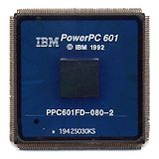

**Figure A1.2: RISC**

* **ARM (Advanced RISC Machines):-**

An ARM processor is one of a family of [CPUs](https://whatis.techtarget.com/definition/processor) based on the [RISC](https://search400.techtarget.com/definition/RISC) (reduced instruction set computer) architecture developed by Advanced RISC Machines (ARM). ARM makes 32-bit and [64-bit](https://searchdatacenter.techtarget.com/definition/64-bit-processor) RISC [multi-core processors](https://searchdatacenter.techtarget.com/definition/multi-core-processor). RISC [processors](https://whatis.techtarget.com/definition/microprocessor-logic-chip) are designed to perform a smaller number of types of computer [instructions](https://whatis.techtarget.com/definition/instruction) so that they can operate at a higher speed, performing more millions of instructions per second ([MIPS](https://searchitoperations.techtarget.com/definition/MIPS-million-instructions-per-second)).  By stripping out unneeded instructions and optimizing pathways, RISC processors provide outstanding performance at a fraction of the power demand of [CISC](https://whatis.techtarget.com/definition/CISC-complex-instruction-set-computer-or-computing) (complex instruction set computing) devices.

ARM processors are extensively used in consumer electronic devices such as [smartphones](https://searchmobilecomputing.techtarget.com/definition/smartphone), [tablets](https://searchmobilecomputing.techtarget.com/definition/tablet-PC), multimedia players and other mobile devices, such as [wearables](https://internetofthingsagenda.techtarget.com/definition/wearable-computer). Because of their reduced [instruction set](https://whatis.techtarget.com/definition/instruction-set), they require fewer [transistors](https://whatis.techtarget.com/definition/transistor), which enable a smaller die size for the integrated circuitry ([IC](https://whatis.techtarget.com/definition/integrated-circuit-IC)). The ARM processor’s smaller size, reduced complexity and lower power consumption makes them suitable for increasingly miniaturized devices.

ARM processor features include:

* Load/store architecture.
* An [orthogonal](https://searchstorage.techtarget.com/definition/orthogonal) instruction set.
* Mostly single-cycle execution.
* Enhanced power-saving design.
* 64 and 32-bit execution states for scalable high performance.
* [Hardware virtualization](https://searchservervirtualization.techtarget.com/definition/hardware-virtualization) support.

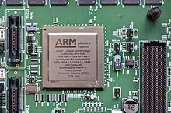

**Figure A1. 3: ARM**

* **DSP (Digital Signal Processors):**

Digital Signal Processors (DSP) take real-world signals like voice, audio, video, temperature, pressure, or position that have been digitized and then mathematically manipulate them. A DSP is designed for performing mathematical functions like "add", "subtract", "multiply" and "divide" very quickly.

Signals need to be processed so that the information that they contain can be displayed, analyzed, or converted to another type of signal that may be of use. In the real-world, analog products detect signals such as sound, light, temperature or pressure and manipulate them. Converters such as an Analog-to-Digital converter then take the real-world signal and turn it into the digital format of 1's and 0's. From here, the DSP takes over by capturing the digitized information and processing it. It then feeds the digitized information back for use in the real world. It does this in one of two ways, either digitally or in an analog format by going through a Digital-to-Analog converter. All of this occurs at very high speeds.

A DSP contains these key components:

* **Program Memory**: Stores the programs the DSP will use to process data
* **Data Memory:** Stores the information to be processed
* **Compute Engine:** Performs the math processing, accessing the program from the Program Memory and the data from the Data Memory
* **Input/ Output:** Serves a range of functions to connect to the outside world

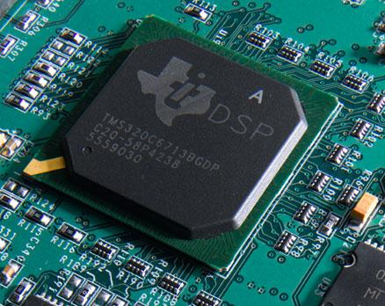

**Figure A1. 4: DSP**

* **SOC (System on a Chip):**

A system on a chip is an [integrated circuit](https://en.wikipedia.org/wiki/Integrated_circuit) (also known as a "chip") that integrates all components of a [computer](https://en.wikipedia.org/wiki/Computer) or other [electronic system](https://en.wikipedia.org/wiki/Electronics). These components typically (but not always) include a [central processing unit](https://en.wikipedia.org/wiki/Central_processing_unit) (CPU), [memory](https://en.wikipedia.org/wiki/Computer_memory), [input/output](https://en.wikipedia.org/wiki/Input/output) ports and [secondary storage](https://en.wikipedia.org/wiki/Computer_data_storage#Secondary_storage) – all on a single [substrate](https://en.wikipedia.org/wiki/Wafer_(electronics)) or microchip, the size of a coin.[[1]](https://en.wikipedia.org/wiki/System_on_a_chip#cite_note-2) It may contain [digital](https://en.wikipedia.org/wiki/Digital_signal_(electronics)), [analog](https://en.wikipedia.org/wiki/Analog_signal), [mixed-signal](https://en.wikipedia.org/wiki/Mixed-signal_integrated_circuit), and often [radio frequency](https://en.wikipedia.org/wiki/Radio_frequency) [signal processing](https://en.wikipedia.org/wiki/Signal_processing) functions, depending on the application. As they are integrated on a single substrate, SOC consume much less power and take up much less area than multi-chip designs with equivalent functionality. Because of this, SoCs are very common in the [mobile computing](https://en.wikipedia.org/wiki/Mobile_computing) (such as in [Smartphones](https://en.wikipedia.org/wiki/Smartphone)) and [edge computing](https://en.wikipedia.org/wiki/Edge_computing) markets. Systems on chip are commonly used in [embedded systems](https://en.wikipedia.org/wiki/Embedded_system) and the [Internet of Things](https://en.wikipedia.org/wiki/Internet_of_things).

Systems on Chip are in contrast to the common traditional [motherboard](https://en.wikipedia.org/wiki/Motherboard)-based [PC](https://en.wikipedia.org/wiki/Personal_computer) [architecture](https://en.wikipedia.org/wiki/Computer_architecture), which separates components based on function and connects them through a central interfacing circuit board. Whereas a motherboard houses and connects detachable or replaceable components, SoCs integrate all of these components into a single integrated circuit, as if all these functions were built into the motherboard. A SoC will typically integrate a CPU, graphics and memory interfaces, hard-disk and USB connectivity, [random-access](https://en.wikipedia.org/wiki/Random-access_memory) and [read-only](https://en.wikipedia.org/wiki/Read-only_memory) [memories](https://en.wikipedia.org/wiki/Computer_memory) and secondary storage on a single circuit die, whereas a motherboard would connect these modules as [discrete components](https://en.wikipedia.org/wiki/Discrete_components) or [expansion cards](https://en.wikipedia.org/wiki/Expansion_card).

A SoC integrates a [microcontroller](https://en.wikipedia.org/wiki/Microcontroller) or [microprocessor](https://en.wikipedia.org/wiki/Microprocessor) with advanced peripherals like [graphics processing unit](https://en.wikipedia.org/wiki/Graphics_processing_unit)(GPU), [Wi-Fi](https://en.wikipedia.org/wiki/Wi-Fi) module, or one or more [coprocessors](https://en.wikipedia.org/wiki/Coprocessor).[[4]](https://en.wikipedia.org/wiki/System_on_a_chip#cite_note-8) Similar to how a microcontroller integrates a microprocessor with peripheral circuits and memory, an SoC can be seen as integrating a microcontroller with even more advanced [peripherals](https://en.wikipedia.org/wiki/Peripheral).

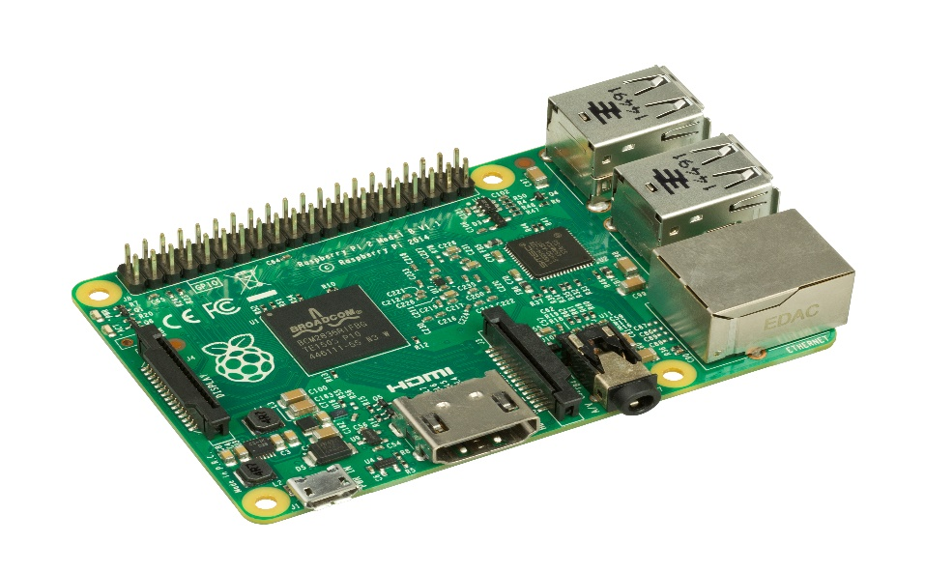

**Figure A1.5: SOC**